York Region Condominium Corporation No. 845
Building Address:
81 Townsgate Drive
Thornhill, Ontario
L4J 8E6

Telephone (905) 709-1539
Fax (905) 709-3249 Email: yrcc845@mrcm.ca
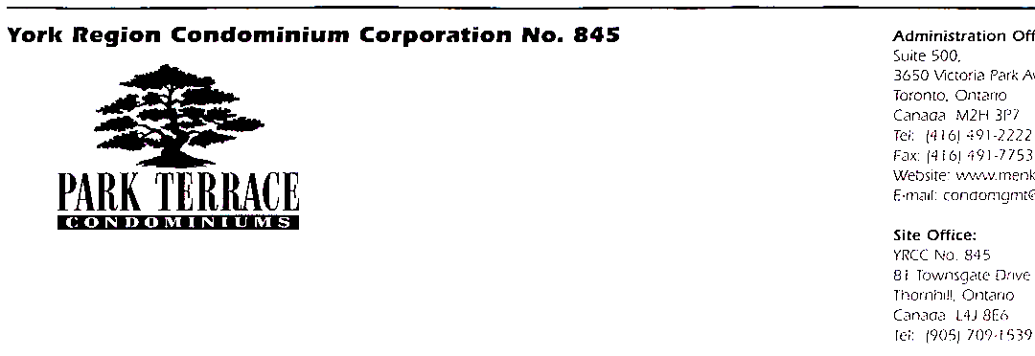

Due to the increased number of pets in the building compared to original occupancy and for emergency purposes, please complete this form for our records.

PET REGISTRATION FORM

Suite No: _________

Resident Name: _____________________________

Pet Name: ________________________

Age: _____________________ Breed: _____________________

Sex: _____________________ Weight: ____________________

Last Vaccination: _____________________________

I/We hereby understand and agree to the Rules and Regulations of YRCC845 with respect to the unit(s) and/or common elements and pets within the building.

Signature: ____________________________ Date: _____________

MAPLE RIDGE COMMUNITY MANAGEMENT
Agents for and on Behalf of YRCC No. 845

